# CASE STUDY 1 Djanogly City Academy

# Using PiratePad and Corkboard.It to support Poetry writing in a Year 9 English lesson

Dr Helen Boulton

# \\DCAN-NAS1\Staff\P00AYE\Need to print\SAM_1082.JPG

## BACKGROUND AND RATIONALE

This case study focussed on a poetry module in Year 9 English lessons. A PGCE secondary trainee on an Information Communications Technology strand was partnered with an experienced English teacher who was keen to introduce new technologies into the classroom. This project took place at Djanogly City Academy in Nottingham. Djanogly City Academy is a member of the Djanogly family of schools which, together, provide education for 3 to 19 year olds in the areas around Hyson Green and Sherwood in Nottingham, which is an area of rich and diverse cultures. The school’s academy specialises in ICT, but in this case study the English teacher was inexperience with using Web 2.0 technologies to enhance the subject and engage students in learning.

Initially the eLearning Director attended the training session that was held at Nottingham Trent University at the start of the project. From the range of software discussed at this session the eLearning Director felt that Etherpad would help to support the pupils in writing poetry. The English teacher agreed with this choice and developed a short scheme of work where both software packages would be utilised. Corkboard was to be introduced for pupils to share ideas for a poem they would be writing and Etherpad was chosen to support pupils in writing poems, sharing their poems, supporting each other in writing their poems and identifying elements of poetry writing such as synonyms and metaphors. However, problems were experienced with Etherpad and the school firewall so PiratePad, which is similar to Etherpad, was utilised.

The group who took part in the project were a Year 9 mixed gender group comprising 18 pupils, 12 of whom have English as a second language including Bengalo, Polish, Slovakian, Chinese and Portuguese. Eight pupils were on the SEN register, with 7 on the School Action register and one pupil on the School Action Plus register. Four pupils were also recognised as ‘disaffected’ by the school, having problems in engaging in lessons.

## INFORMATION ON WHAT HAPPENED

This Year 8 English group were working on a project which focussed on poetry writing in preparation for Year 9 studies. The project took place in a double lesson lasting 100 minutes. The lesson plan can be found in Appendix A. The key learning outcomes for this lesson were:

|  |  |
| --- | --- |
| 1 | * **Spot metaphors, similes and onomatopoeias (level 3).** |
| 2 | * **Understand the effect of metaphors, similes and onomatopoeias (level 4).** |
| 3 | * **Make a poem/ song which uses similes, metaphors and onomatopoeias (level 5).** |

The presentation created to support this lesson can be found in Appendix B. Pupils had been introduced to the key terms of metaphors, similes and onomatopoeias in the previous lesson. On slide 2 of Appendix B you can see a starter activity that was used to help the group work with students being asked to recall what these different key terms meant through writing an example of each one, then swapping with a partner to identify examples. The learning objectives were then shared (see Appendix B slide 3).

The group was introduced to Pirate.pad which had been set up prior to the lesson with pupils in different groups (see slide 4), and instructions within each Pirate.pad area. The students clicked a link to access their group’s Pirate.pad area thus enabling quick access and reducing potential errors in typing in long URLs (web addresses). The way in which Pirate.pad was utilised can be seen through the lesson plan (Appendix A). As can be seen the lesson was broken down into shorter episodes. Throughout the time Pirate.pad was being used in the lesson the students were encouraged to use the ‘chat’ area of the software; allowing students to work collaboratively using the chat feature to communicate with each other and with other groups for additional support. The teacher and Teaching Assistant both had access to the ‘chat’ area thus enabling them to see when students needed help and support and helping them to intervene quickly to respond to these queries and ultimately to keep a good pace throughout the lesson. The teacher and teaching assistant also monitored the timeline feature in each group’s Pirate.pad which allowed them to see how students had edited their work and progression with tasks; this feature also enabled them to check whether students copied and pasted work from the internet rather than creating the text themselves.

Towards the end of the lesson the students were introduced to Corkboard.It and asked to write how they felt about the lesson and how they would develop their work in the next lesson. Using Corkboard. This was easy to set up and only required one username and password which could be set up very simply and given to the students. Students could sign in at the same time as each other and edit it. This software enabled them to all see each other’s comments, thus again providing a supportive environment particularly in sharing what they needed to do in the next lesson.

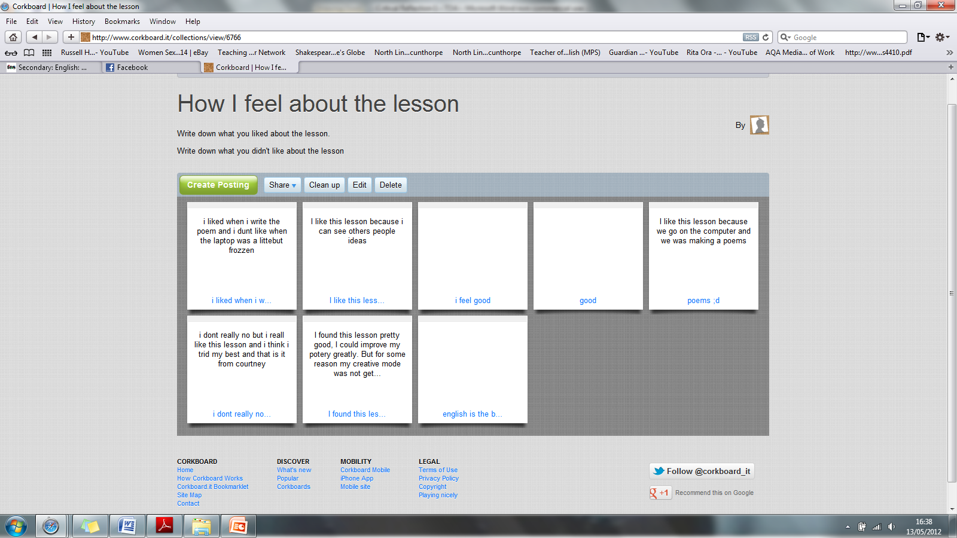

## BENEFITS

### IMPACT IN THE CLASSROOM

#### Impact on pupils:

The positive impacts were:

* [In general the use of ICT helped students improve their literacy. The students with English as a second language (EAL) in the class were able to use Google Translate to help with their writing.](file:///C:\Users\Helen%20Study\Dropbox\Work\TDA%20Project%20case%20study\Jahadul%20and%20Essa.mp4)
* Using the online Chat facility in Piratepad meant [students could speak to each other without having to move and could give each other feedback as to how to improve their work.](file:///C:\Users\Helen%20Study\Dropbox\Work\TDA%20Project%20case%20study\Jessica,%20Djanogly_dj.mp4) Learning became ‘fun’.
* [Students could also look up words to use and improve their spelling.](file:///C:\Users\Helen%20Study\Dropbox\Work\TDA%20Project%20case%20study\Nadia,%20Djanogly,%20EAL_dj.mp4)
* As students were writing poetry they could also use the technology to aid their imagination.
* Students enjoyed being able to share their work with each other and communicating with each other through the technology.

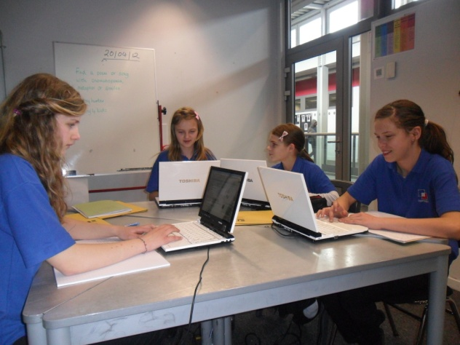

One student commented ‘I liked using this technology because I could work in a group but the teacher could see what I had done so I still got credit for my own work’.

One group of 4 girls said they liked communicating with their friends, and making new friends in their groups. They liked the way the software highlighted their work and said ‘Makes working fun’.

*‘Rather than having to go and ask friends you can send them a chat.’*

*‘Much better because it makes you think more’. ‘It is improving my work particularly [my] English’.*

The group also commented that they were using new words and could ask their friends what words meant.

There were some negative impacts which included:

* Some students became frustrated as they lost their work due to other students deleting their links to their own Piratepads.
* For one student the computer crashed.
* Some students also abused the chat feature to have general conversations instead of focusing on the work set. However, the teacher and TA were quickly able to stop this. Ultimately the classroom was much quieter than usual because of the chat facility.
* Initially some of the students were distracted by the multimodal nature of the internet. In interview the teacher said she thought this would not be the case if the use of this software was embedded in the teaching style for this group.

#### Impact on the school

* As a result of the project there was a CPD meeting on using web 2.0 technologies soon after the use in the project lessons to encourage teachers to use these technologies more in the classroom. The school is currently awaiting materials from this project to develop further CPD sessions for teachers from all subjects.
* Teachers and TAs believed that it helped students to learn and improve their literacy skills.
* The use of this software also made the lessons more student-led and encouraged students to help each other’s learning and development.
* It was agreed that it would be good to incorporate web 2.0 technologies into a scheme of learning.

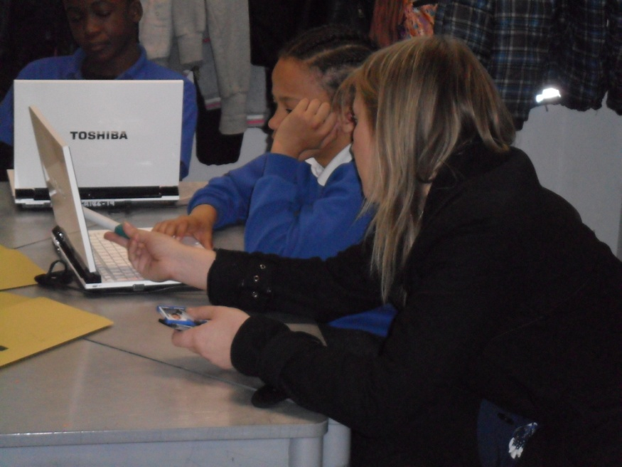

The English teacher, who was part of the project, was not a confident user of technologies other than MS software such as Word. She commented that she had not used Web 2.0 technologies and had not seen how they could be used in her subject area. Being involved in the project had given her new ideas but she lacked confidence with using computers, especially when they didn’t work. She said that working with the trainee had been great because the trainee had set the project up, created the Piratepad and Corkboard and was there to help with any problems. She would definitely have a go at using this software in the future and knows other teachers will use it. She said that while there is not a lot of technology used in the school it was mainly Word Excel etc:

*‘this is very different and I think it is more exiting and engaging for the pupils’.*

#### Impact on trainee teacher

Observations and interviews with the trainee teacher indicated that she had grown in confidence in using Web 2.0 technologies in her classroom. She was pleased at the way the students had embraced the new technology, worked collaboratively through the software and improved their literacy skills through this multimodal approach. She commented that this particular project had engaged those pupils who she had previously found difficult to engage in learning; she put this down to the use of the technologies. The trainee teacher working in partnership with an experienced core subject teacher helped her to explore the use of Web 2 technologies that she hadn’t previously used. She gained in confidence in using technologies as the project developed, for example she had initially planned to use Etherpad, but the school firewall wouldn’t allow her access, so in discussion with the teacher she successfully changed to PiratePad. She also commented that using Piratepad she had to set up the groups beforehand which gave her opportunity to group pupils who had not previously worked together and think about the strengths of each group. The trainee observed that the teacher doesn't need to keep stopping the pupils who were on task more than in other lessons and were able to work through supporting themselves. She commented that the pupils were also able to use the technology that supports them at home such as Google translate. She commented in her reflective diary ‘Students with EAL were using Google translate to help them write what they wanted to say. The teaching assistant could help one of the students and she commented that when students had assessed the pupil his writing was more towards a level 4 rather than a 2/3 which he usually works at. Students could also help each other in the mixed ability groups thus clarifying words and the task they had to complete’.

*‘I would like to use web 2.0 technologies in my lessons in the future and I now know how easy it is to set them up as long as they work and are not blocked by the school.’*

*‘It was good to see students supporting each other and allowed me to have more time to talk to students as individuals and facilitate learning rather than being at the forefront.’*

Comment from the trainee’s reflective diary states ‘Students enjoyed using the Web 2.0 technologies. They were eager to understand how it worked and they allowed students to engage with other students in the class that they may not have communicated with before. It enhanced a collaborative working environment and allowed students to mentor and support one another. The teaching assistant could also aid other students in the class rather than be limited to helping one student. The laptops aided low ability and EAL students as they could research good examples of poetry, translate words and visualise things through Google images.’

## FINAL COMMENTS

### Lessons learnt

Overall the project integrated Web 2.0 technologies into the classroom. The data collected provides evidence that the students achieved higher levels of literacy and those students identified as disaffected were engaged in the lessons where the technologies were being used. The main point of learning from this project is that Web 2.0 technologies need to be embedded into a scheme of learning to enable both the students, teachers and teaching assistants to become familiar and confident with a range of technologies to use in learning and teaching.

Key points of learning to share with other schools considering similar projects are:

* Technology can help students of low ability through collaborative working.
* Technology can help EAL students as they can translate words and communicate what they want to say/write effectively.
* Students can look up spellings and interesting words.
* Students enjoy sharing each others’ work and being able to peer assess it.
* TAs can be more involved in lessons and also help in feedback, support and monitoring students’ progress through using Web 2.0 technologies.
* Check that the technology works on the students’ computers – students often have different access rights some of the technologies did not work.
* Web 2.0 technologies should be used with purpose rather than being used for technology’s sake – using technology without purpose means that students are easily distracted and off task.
* Students should be encouraged to use a range of Web 2.0 technologies and given easier access to appropriate technologies for learning.

### What next?

Interviews with the teacher and Teaching Assistant indicate that there is a need for further CPD in the use of Web 2.0 technologies. Knowledge of the range of technologies and their uses within different subjects needs to be shared more widely and teachers empowered through CPD to increase their knowledge and confidence in how to use them appropriately to support learning and teaching.

## RESOURCES:

Session plan Appendix A

Teacher’s PowerPoint Appendix B

## APPENDIX A

**[Nottingham Trent University logo](http://www.ntu.ac.uk/)Lesson Title: TDA Project Lesson: Poetry**

|  |  |  |  |
| --- | --- | --- | --- |
| Date of lesson | 26/04/12 | Lesson No | 7 of 16 |
| Lesson Duration | 100 minutes | Year/Class | 8B EN5 |
| Total Pupils | 18 | Ability | Level 3 - 5 |

|  |  |
| --- | --- |
| Aim of the lesson : how does this lesson fit into the school’s bigger picture, SOW and/or KS3/KS4/5 PoS or Specification? | |
| Year 8 students are studying poetry in preparation for year 9 studies. Before this they had studied the novel “The Wreck of the Zanzibar’. | |
| Lesson Learning Objectives  Learners will develop their (skills/knowledge/understanding/creativity and thinking/awareness and values) by learning how …. | |
| 1 | * **Spot metaphors, similes and onomatopoeias (level 3).** |
| 2 | * **Understand the effect of metaphors, similes and onomatopoeias (level 4).** |
| 3 | * **Make a poem/ song which uses similes, metaphors and onomatopoeias (level 5).** |
| **Differentiated Learning Outcomes**  By the end of the session (all/most/some) of the learners will be able to know/understand/  demonstrate/explain/identify/etc. | |
| Level 3will **only have used 2/3 metaphors, similes and onomatopoeias in their**  **poem/song.** | |
| Level 4 will **use metaphors, similes and onomatopoeias throughout their poem/song.** | |
| Level 5 will **make a poem/ song which uses similes, metaphors and onomatopoeias for effect.** | |
| **Project Focus Points and Evaluation of Effectiveness:** | |
| **Project Focus Point 1 (Web 2.0 Technology):** What Web 2.0 technology are you using, why and how are you using it?  **Piratepad**  **Corkboard.It**  How will I ***measure the impact*** of this focus point in the lesson (success criteria)?:  **I will have students write notes on corkboard on what they enjoyed about the lesson and why and have the students fill out student voice questionnaires as well as interview individuals.** | |
| **Project Focus Point 2 (Improve Literacy):** How will this lesson help to improve literacy skills within mylesson?  **Students can help each other define key words. Students can also put these into practice through highlighting examples of these in song lyrics. Students with EAL can use Google translate**  How will I ***measure the impact*** of this focus point in the lesson (success criteria)?:  **Students have to produce a poem/song lyrics that fit certain criteria, this can then be judged against their usual levels of attainment.** | |
| Differentiation strategy and working with other adults (e.g. teacher assistant (TA), mentor, technician) | |
| **The teaching assistant sits with one student in the class with SEN. He is also low ability. I will email the powerpoint slides to the teaching assistant so she can help the other students in the class as well as support me and the student she sits next to. Using Piratpad will enable the TA to monitor progress of all the pupils – alongside teacher – thus ensuring a good pace to the lesson** | |
| **What consideration needs to be given prior to the lesson?** (i.e. setting expectation rules on how to use the technology in lesson? How you will save the produced work for assessment? etc) | |
| **Setting the expectations that the computers will be used sensibly, that students will keep on task. I will have to set up the lesson through instructions on the powerpoint and the piratepad. I need to ensure students understand how to use the chat facility appropriately.** | |

**Session Sequence**

|  |  |  |  |  |
| --- | --- | --- | --- | --- |
| Time and duration  **(mins)** | **Teacher’s activity** | **Learner’s activity**  *Please highlight the episodes in which the project focus points are being addressed?* |  | **AfL strategies used in the lesson** |
| 10mins | **Starter (& settler task if needed) task**:  Key questions to ask:  What is a simile?  What is a metaphor?  What is an onomatopoeia?  Why do we use these?  Can you give me any examples? | Students collect a laptop and log in. Whilst students are waiting for the laptop to load they write down examples of similes, metaphors and onomatopoeias.  These are then swapped with their partner and their partner decide whether they are similes, metaphors or similes.  Teacher asks for examples of metaphors, similes and onomatopoeias that the students have created. |  | Peer assessment. |
|  |
| 5mins | **Episode 1:**  Teacher introduces learning objectives and what the students will be doing in the lesson.  Key questions to ask:  What do we mean by the word effect?  Does anyone have any questions? | Introduction to learning objectives:   * **Spot metaphors, similes and onomatopoeias (level 3).** * **Understand the effect of metaphors, similes and onomatopoeias (level 4).** * **Make a poem/ song which uses similes, metaphors and onomatopoeias (level 5).**   Teacher introduces what the lesson will focus on (the creation of their own poem/song lyrics). |  | Teacher assessment. |
|  |
| 5mins | **Episode 2:**  Key questions to ask:  Opportunity for students to ask any questions if they are having trouble accessing the links etc.  Is everyone ok?  Does anyone need any help? | Teacher tells students that they will be working in groups and shows them the groupings. Teacher explains that students need to open up their emails as she has sent them an email with the slides on so that they can click on the links.  Teacher demonstrates how to do this and what the page should look like that they are on.  Teacher tells students to choose a colour and write their name next to it, read the instructions and complete the tasks. |  | Teacher assessment. |
|  |
| 15mins | **Episode 3/or Mini Plenary:**  Key questions to ask:  On piratepad:  What is a simile?  What is a metaphor?  What is an onomatopoeia?  What techniques did you find?  What technique is it?  What effect does it have?  Why has it been used? | Students complete tasks that have been set for them.  Students answer the questions and then spot them in Jessie J’s song ‘Domino’ by highlighting the techniques.  Students feedback their findings and students say what effect they have. |  | Peer assessment.  Teacher assessment.  Self assessment.  Teaching assistant assessment. |
|  |
| 5mins | **Episode 4:**  Key questions to ask:  What could your song/poem be about? | Students are asked to go back to the powerpoint and click on the link and log in. Students write their ideas down for what a poem/song could be about to share with the group.  Teacher tells students to look at what other students have written and reads some examples out. |  | Teacher assessment.  Peer assessment. |
| 50mins | **Episode 5:**  Key questions to ask:  Teacher supports class with any questions they may have. | Students create their own piratepad and begin typing their own poem/song. Students can research pre-existing songs/poems to aid them as well as use Google translate and Google images. |  | Teacher assessment.  Teaching assistant assessment. |
| 10mins | **Plenary task:**  Key questions:  What level do you think your group is working at?  Why are they working at that level?  How can they improve?  What is good about their poem/song?  What did you like about the lesson?  What did you not like about the lesson. | Students to read each others’ work by copying and pasting their piratepad link into the group piratepad. Students assess each student’s progress against the success criteria and comment on what they thought was good about it, how to improve and a level.  Students lastly visit corkboard again and write on a note what they liked about the lesson/didn’t like and how to develop their work in the next lesson.  Students pack away and log off computers and put them back. |  | Peer assessment.  Teacher assessment. |
|  |

|  |  |
| --- | --- |
| **Homework task:**  **Date Due:** | **Find a poem/song lyrics that contain similes, metaphors and onomatopoeias and identify them.**  **3/05/12** |
| **Duration of task:** | **30mins** |
| **Links to learning:** | **This will consolidate students’ learning a of poetry and ICT as students have to research a poem/song and then identify the techniques used.** |

|  |
| --- |
| Records and Risk Assessment |
| Risk assessment: Students may trip over the laptop charger wires or may drop/break the laptops. |

|  |
| --- |
| Preparation prior to lesson |
| * Set up corkboard.it work area with student log ins (software will automatically email students with log on information) * Set up Piratepad and organise students into different groups. * Upload instructions for tasks to be completed into Piratepad to enable student-centred approach. * Ensure students, teachers and teaching assistants are able to access the software and understand how to use the chat area in Piratepad. |

## Appendix B Lesson Power Point

Slide 1 Slide 2

 

Slide 3 Slide 4

 

Slide 5 Slide 6

 

Slide 7 Slide 8

 

Slide 9 Slide 10

 